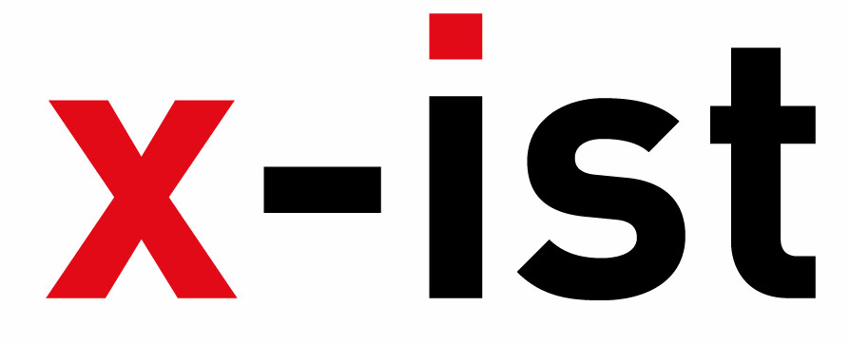 | Abdi İpekçi Caddesi Kaşıkçıoğlu Apt. No:42 D:2 34365 Nişantaşı İstanbul  www.artxist.com  info@artxist.com  T. +90 212 291 77 84 F. +90 212 343 69 35 | PRESS RELEASE

NOTHING PERSONAL

Erkut Terliksiz cannot disguise himself in his expressionist paintings. He can be traced through
the details of his work that combine dream and reality. Painting is an instinctive necessity for him.
Unlike life, his impression of life flows spontaneously and without plans onto hiswork. His journey
is not bounded with rules and limitations; instead it allows freedom and amorphous figures.
Terliksiz’s subconscious and memories haunt him during this only time where he can actually be solitary.
His works, which seem like fiction at first but involve personal tales, are presented to the audience
to let their own stories come out.

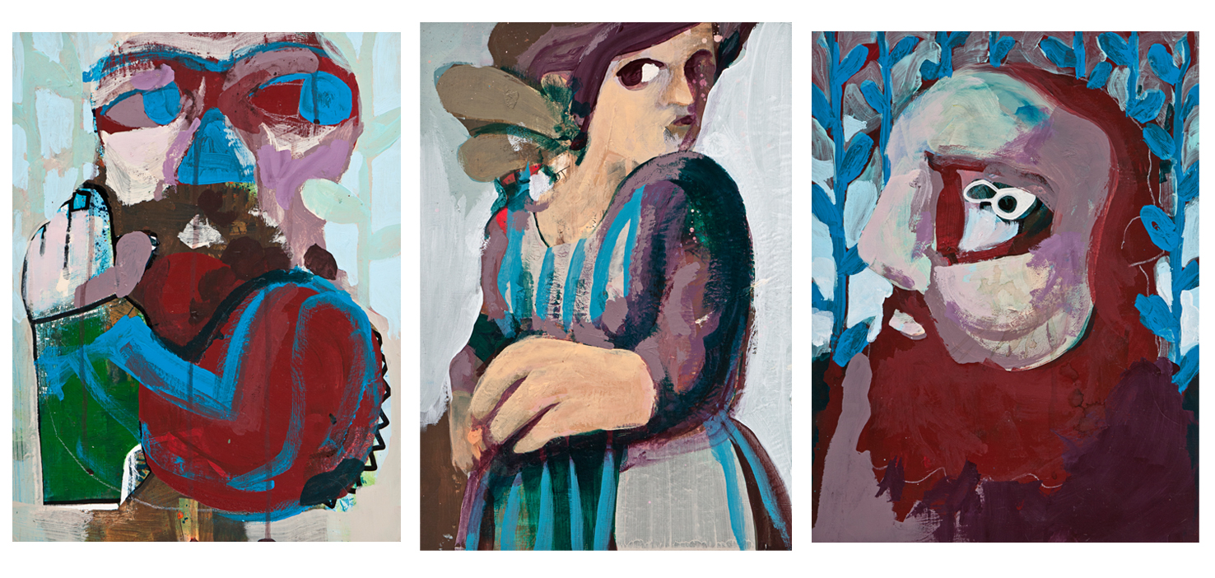

Erkut Terliksiz, Family Bonds II, Acrylic on paper, 35 x 25 – 39 x 30 – 40 x 30 cm, 2012

Unlike his previous solo shows at x-ist, “Debut” (2007) and “Till We Meet Again” (2010), in this new exhibition "Nothing Personal" Terliksiz paints more observable expressions in his new portraits. The looks of the characters not only bring out the emotional side of the story but also hint to the relationship among serial works. The artist’s recent focus on using experimental material is also evident. Terliksiz, who previously included everyday material such as tea bags, wood and cardboard in his work, this time exhibits a three dimensional painting with sculptural qualities.
Erkut Terliksiz’s new show, “Nothing Personal”, can be seen between May 31-June 23, 2012 at x-ist.

ERKUT TERLİKSİZ, Adana, 1978

Terliksiz graduated from the Mimar Sinan Fine Arts Faculty, Department of Illustration in 2002. The artist, who took place in several group exhibitions in Australia, England, Spain and Germany, exhibited his works in x-ist for the first time in the group show Intersection I (2005). Later, his first solo show Debut (2007) and Till We Meet Again (2010) were exhibited at x-ist. Among the international art fairs Terliksiz participated in are artFair06 Cologne, Contemporary Istanbul 06, 07, 09, 10 & 11, CIGE 2008 - China International Gallery Exposition (Beijing, China), Start-2009 (14th European Contemporary Art Fair, Strasbourg, France), Vienna Art Fair 2011, Scope Basel 2011 and Art Dubai 2012. He also participated in the group shows “Thanks for Sharing” in 2010 (Leipzig, Germany) and ‘Confessions of Dangerous Minds’ in 2011 (London, UK).

